MAE 598 MEDM: Lab # 5

Group 9: Tushar Vishwanath, Anand Anil Kumar, Sobha Srujana Patri, Tolemy Nibi

MAE 598: Mechatronics Engineering for Design & Manufacturing (MEDM)

Professor Cindy (Xiangjia) Li

May 1, 2024

Question - Bonus Lab HW5

* Get familiar with switches.
* Get exposure with close loop control.
* Constructing a linear motion system with all components.

Task1 Runs the stage that moves from the start point to the endpoint until touches the microswitch.

Task2 Uses the microswitch as the direction change moving the platform from one side to another side and going back.

# Physical Set Up

Figure 1 & 2

Circuit Diagram with connections.

|  |
| --- |
|  |
| Figure 1 |

|  |
| --- |
|  |
| Figure 2 |

**Circuit Schematic Diagram**

Figure 3

Circuit Schematic Diagram

|  |
| --- |
|  |
| Figure 3 |

Figure 4

Lead Screw Mechanism

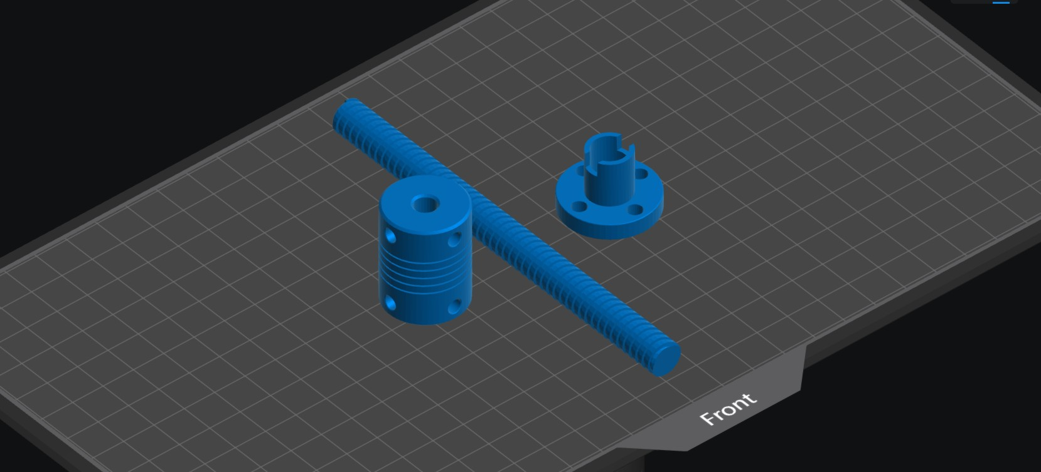

Figure 5

Coupler

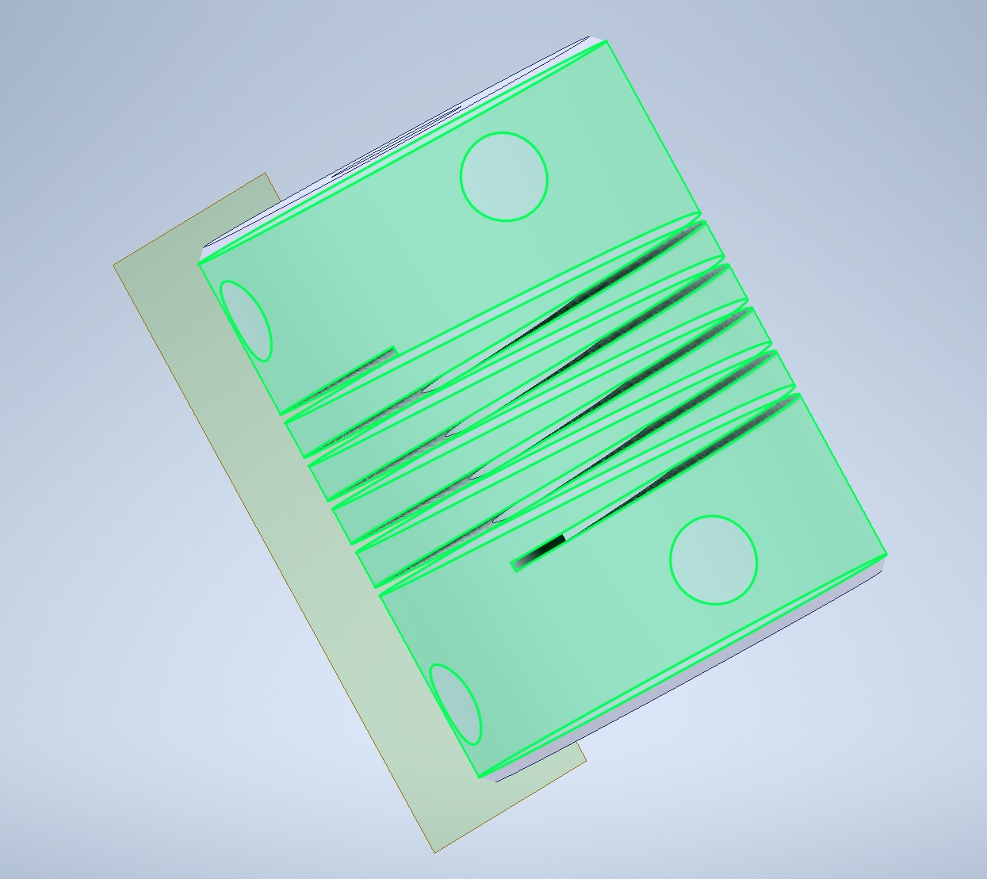

●

Figure 6

Lead Screw

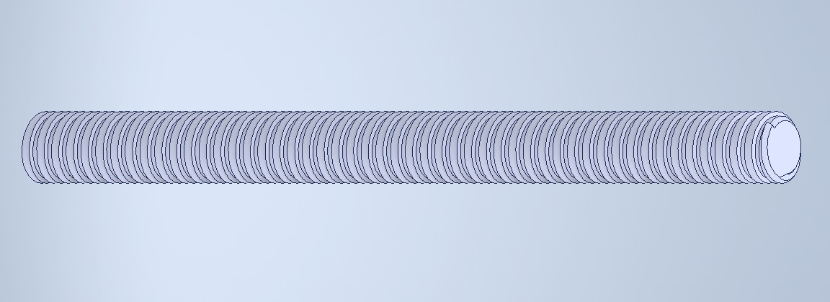

Figure 7

Circle Screw

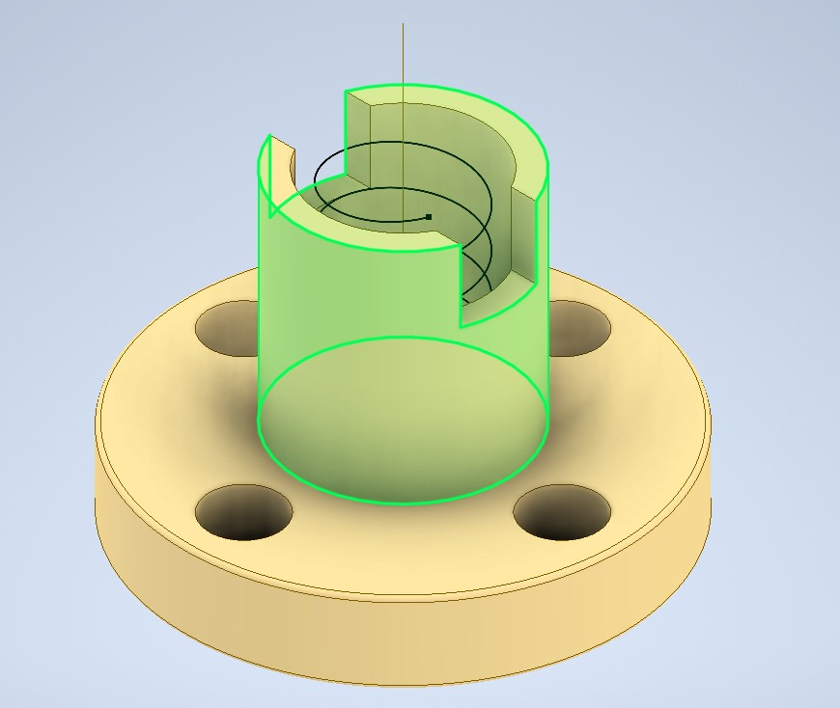

[3D printing simulation (Chitubox)](https://drive.google.com/file/d/1i-1SyVFCkfFOmpdiZGBoNgs1x4Y3EUP1/view?usp=sharing)

TinkerCAD was used to model this circuit.

The motor driver connects to the stepper motor enabling polarity switch and to the 5V power supply. The motor connects to a lead screw that rotates to drive the circle screw in one direction till it reaches the microswitch.

The microswitch detects the screw and directs the motor driver to switch polarities. This drives the motor to rotate in the opposite direction pulling the screw away from the microswitch. All components are connected to the Arduino Uno for signal and power.

# Code(s)

|  |
| --- |
| // Define motor control pinsconst int motorIN1 = 2; // Example pin for motor control (IN1)const int motorIN2 = 3; // Example pin for motor control (IN2)const int switchPin = 4; // Example pin for microswitch inputvoid setup() {pinMode(motorIN1, OUTPUT);pinMode(motorIN2, OUTPUT);pinMode(switchPin, INPUT_PULLUP);}void loop() {// Check if microswitch is pressedif (digitalRead(switchPin) == LOW) {// If microswitch is pressed, move in the opposite directiondigitalWrite(motorIN1, HIGH); // Set motor directiondigitalWrite(motorIN2, LOW); // Set motor direction} else {// If microswitch is not pressed, move in the forward directiondigitalWrite(motorIN1, LOW); // Set motor directiondigitalWrite(motorIN2, HIGH); // Set motor direction}} |
| Note - In case of spacing issues the txt file has been attached here - [txt](https://drive.google.com/file/d/1TrMbgyknaRW8vBgQ1bUPvcZh8UpTFIST/view?usp=sharing) |